Look at this picture of The Magic Tree:
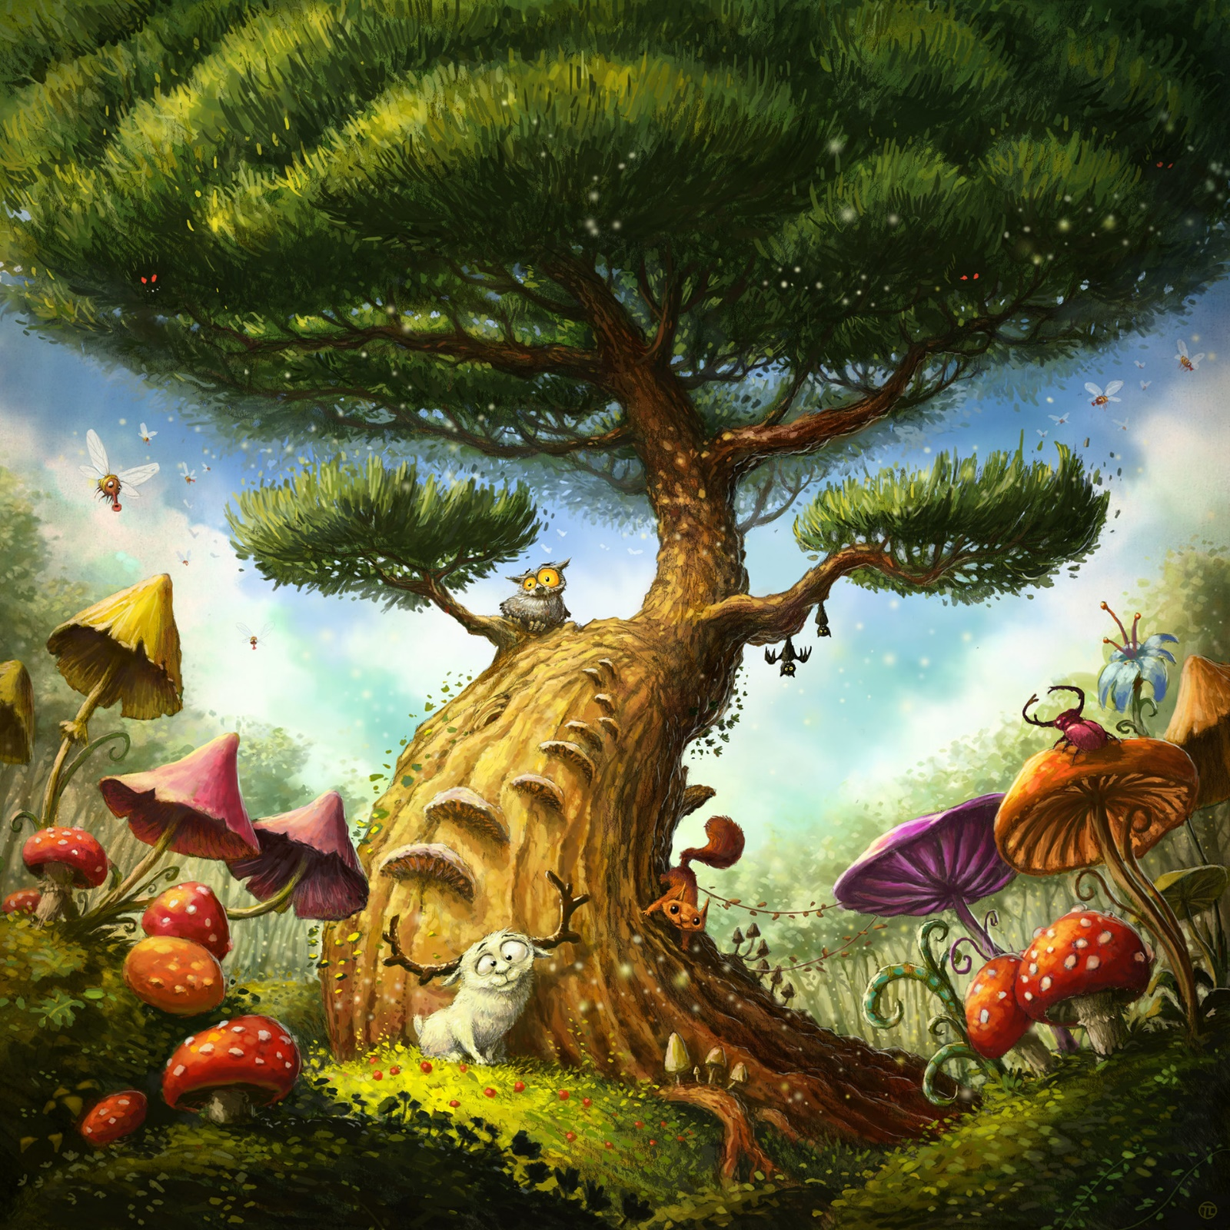
The tree stood tall in the middle of the forest. The bark had begun to peel away in places, one piece at a time but leaving what looked like a set of steps in its place. This tree was different from the other trees in the forest…

